**WT PRACTICALS**

**SUBJECT CODE- LPCIT-107**

**COURSE INCHARGE: HANIT KAUR MA’AM**

**SUBMITTED BY:**

**ASTHA**

**IT A-1**

**URN-1905312**

**CRN-1921016**

**LIST OF PRACTICALS**

1. Create a simple web page by writing HTML using a simple text editor, Notepad. Demonstrate the following components of the web page: Page titles and Headings Paragraphs and Inline images

2. Demonstrate the use of Links, Lists and Tables in HTML.

3. Create simple Forms in HTML and demonstrate the use of various form elements like input box, textarea, submit and radio buttons etc.

4. Demonstrate the use of cascading style sheets (CSS) (inline, internal and external) to specify various aspects of style, such as colours and text fonts and sizes, in HTML document.

5. Creation of Web pages using HTML5 and CSS3.

6. Demonstrate the use of Bootstrap Framework.

7. Creating web pages using PHP.

P1. 1. Create a simple web page by writing HTML using a simple text editor, Notepad. Demonstrate the following components of the web page: Page titles and Headings Paragraphs and Inline images

<DOCTYPE! html>

<html>

<head>

<title> My page </title>

</head>

<body>

<center><h1> This is Practical 1</h1>

<hr>

</center>

<img src= "https://www.gndec.ac.in/sites/default/logo.png" alt="GNDEC Logo" width ="1500" height="100">

<p> This page demonstrates the first practical i.e. to create a simple web page demonstrating the components such as page title and headings, paragraphs and inline images. </p>

<br>

<p> For more details you can visit our website by clicking <a href = "https://gndec.ac.in/"> here. </a>

</body>

</html>

**OUTPUT:** 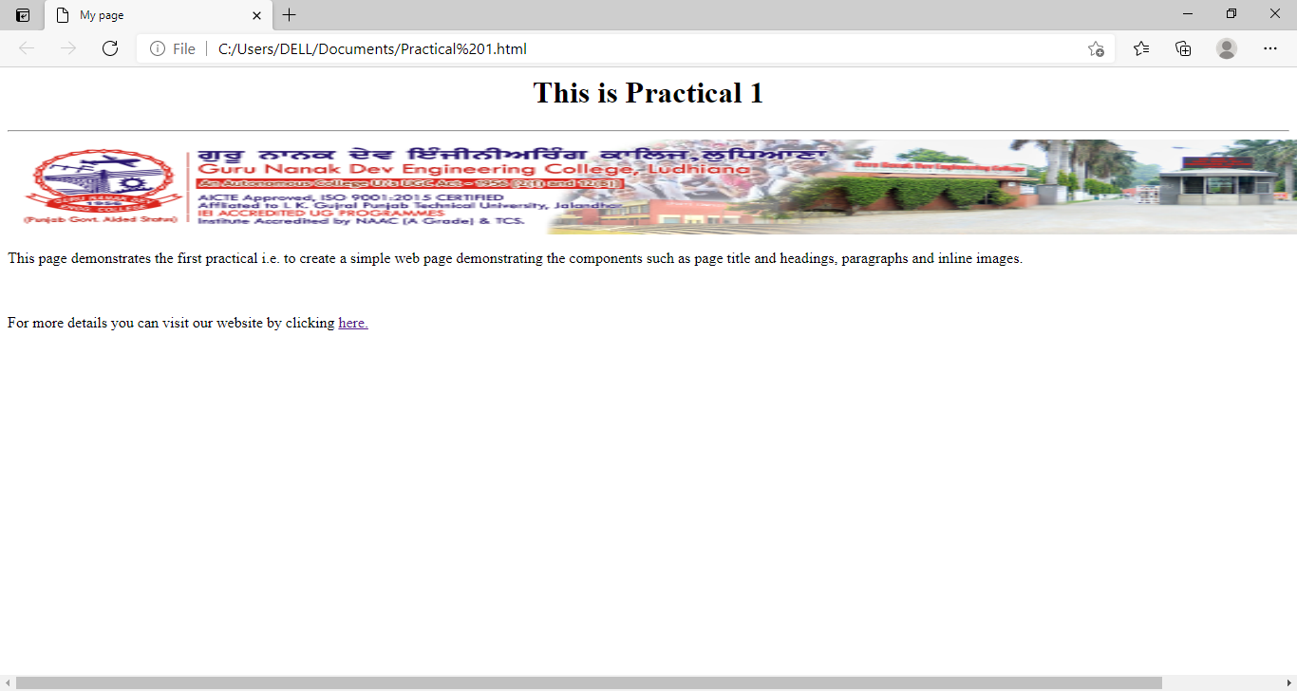

P2. 2. Demonstrate the use of Links, Lists and Tables in HTML.

<DOCTYPE! html>

<head>

<title> Official_Foodelicious </title>

<style>

table, th, td

{

border: 1px solid black;

border-collapse: collapse;

}

th, td {

padding: 15px;

}

</style>

</head>

<body style ="background-color: orange;">

<center> <h1 style="background-color: Tomato;"> FOODELICIOUS!!</h1></center>

<hr>

<h3 text align= center>Want food? It is right here, just one click away. <h3>

<br>

<p style =" color: teal;">Welcome to the official websites of Foodelicious. We bring you tasty and fresh food right at your doorsteps. Food prepared by renowned chefs having expertise in all sort of cousine. </p>

<br>

<table style="width:100%">

<tr>

<th colspan=3><b> Menu is Here<b> </th>

</tr>

<tr>

<th>Sr.No</th>

<th>Food Item</th>

<th>Price</th>

</tr>

<tr>

<td>1</td>

<td>Chicken

<ol>

<li> Karahi </li>

<li> Rawalpindi </li>

<li>Butter</li>

<li> Korma</li>

</ol>

</td>

<td>500</td>

</tr>

<tr>

<td>2</td>

<td>Mutton

<ul type= square>

<li> Lucknawi </li>

<li> Rogan </li>

<li>Reshami</li>

<li>Handi</li>

</ul >

</td>

<td>700</td>

</tr>

<td>3</td>

<td>Biryani

<ul>

<li> Lucknawi </li>

<li> Hydrabadi </li>

<li>Calcutta</li>

<li>Sindhi</li>

</ul>

</td>

<td> 900</td>

</tr>

</table>

<br>

Craving for something sweet. We might have something for you in <a href= "file:///C:/Users/DELL/Documents/Practical%202(2nd).html> here </a>

</body>

</html>

**OUTPUT:**

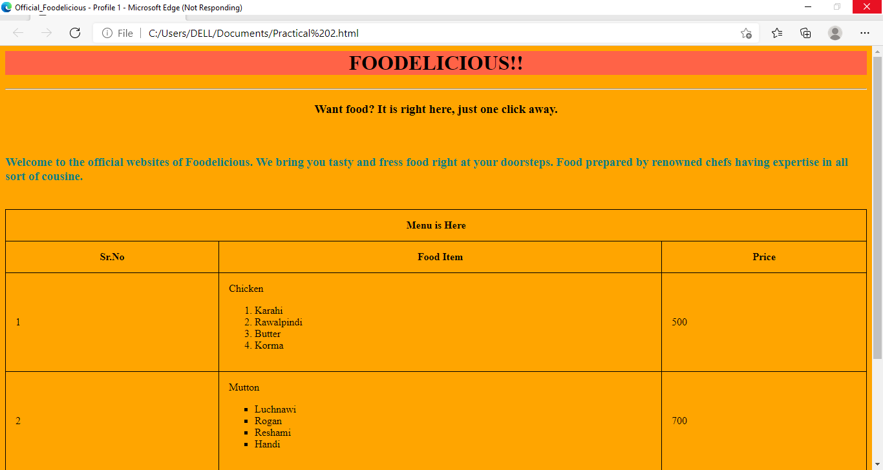

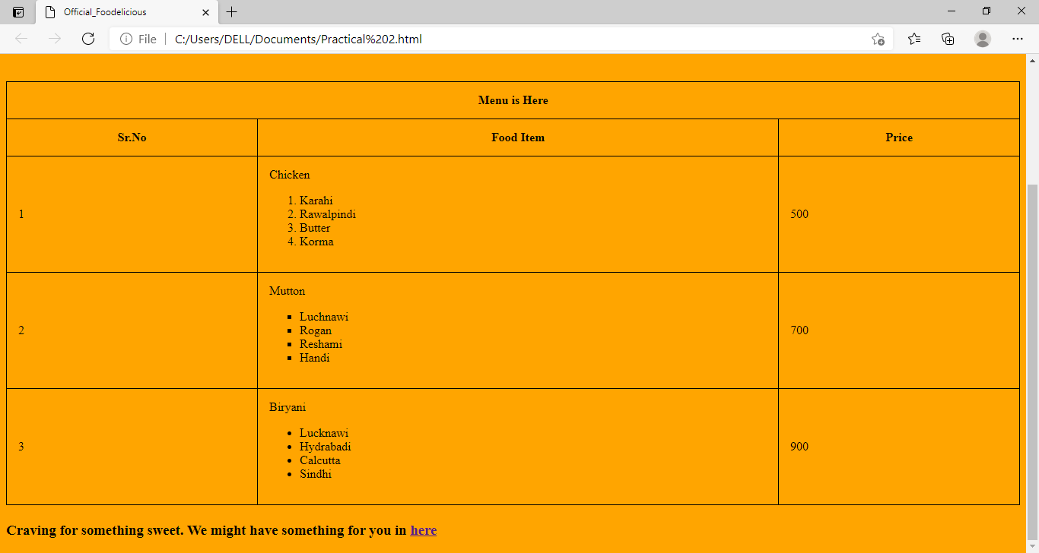

Practicals2nd.html

<!DOCTYPE html>

<html>

<head>

<title> Desserts_Foodelicious </title>

<style>

table, th, td

{

border: 1px solid black;

border-collapse: collapse;

}

th, td {

padding: 15px;

}

th {

text-align: center;

}

</style>

</head>

<body style ="background-color: teal;">

<center> <h1 style="background-color: Tomato;"> FOODELICIOUS!!</h1>

<br>

<h2 text-align=center>Welcome Sweettooth<h2></center>

<table style="width:100%">

<tr>

<th colspan=3><b> Menu is Here<b> </th>

</tr>

<tr>

<th>Sr.No</th>

<th>Desserts</th>

<th>Price</th>

</tr>

<tr>

<td>1</td>

<td>Tiramisu. </td>

<td> 390 </td>

</tr>

<tr>

<td>2</td>

<td>Chocolate mousse in minutes. </td>

<td> 330 </td>

</tr>

<tr>

<td>3</td>

<td>Angel food cake.</td>

<td> 542 </td>

</tr>

<tr>

<td>4</td>

<td>'Not so fried' ice-cream. </td>

<td> 320 </td>

</tr>

<tr>

<td>5</td>

<td>Roasted strawberry crumble. </td>

<td> 450 </td>

</tr>

<tr>

<td>6</td>

<td>Apple and butterscotch pie. </td>

<td> 370 </td>

</tr>

<tr>

<td>7</td>

<td>Almond and date cake.</td>

<td> 620</td>

</tr>

<tr>

<td>8 </td>

<td>Apple cinnamon custard cake. </td>

<td>750</td>

</tr>

<tr>

<td>9 </td>

<td>Apple and blueberry tarts </td>

<td>200</td>

</tr>

<tr>

<td>10 </td>

<td>Shakes

<ul>

<li>chocolate</li>

<li>strawberry</li>

<li>vanilla</li>

<li>butterscotch</li>

<li>black current</li>

</ul>

</td>

<td>150 </td>

</tr>

</table>

</body>

</html>

**OUTPUT:**

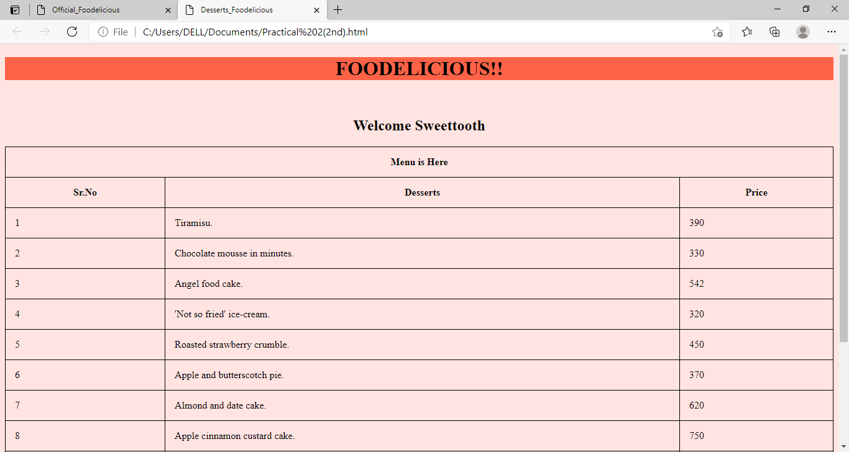

P3. Create simple Forms in HTML and demonstrate the use of various form elements like input box, textarea, submit and radio buttons etc.

<!DOCTYPE html>

<html>

<head> <title>Library Management</title></head>

<body style="background-color: PapayaWhip;">

<div style="background-color: coral; color: black; padding:10px;">

<center><h1><b> LIBERARY MANAGMENT</b> </h1></center></div>

<center><h4 style= "color: maroon;"> Welcome to Readers's Club. <i> A place where people find books and books find people.</i> </h4></center>

Fill out the below form and get a chance to be a part of our reading family.

<center><h3> Membership Form</h3></center>

<form>

<form action="/action_page.php" >

<fieldset>

<legend>Personalia:</legend>

<label for="fname">First name:</label>

<input type="text" id="fname" name="fname" >

<label for="lname">Last name:</label>

<input type="text" id="lname" name="lname" ><br>

<label for= "email"> Email id:</label>

<input type="email" id="email" name="email">

<label for= "dob"> Date of Birth: </label>

<input type= "text" id="dob" name="dob"><br>

<label for= "address"> Address: </label>

<textarea name="address" rows="10" cols="30">

</textarea><br><br>

<lable for="member"> Prior member to any other library</lable>

<select id="member" name="member">

<option value="yes">Yes</option>

<option value="No">No</option>

</select><br>

<label for= "mode"> Mode of Payment: </label><br>

<input type="radio" id="cash" name="mode" value="cash">

<label for="male">Cash</label><br>

<input type="radio" id="cheque" name="mode" value="cheque">

<label for="female">Cheque</label><br>

<input type="radio" id="Card" name="mode" value="Card">

<label for="other">Card</label><br><center>

<button type="button" onclick="alert ("Data Submitted")"> Submit</button></center>

</fieldset>

</form>

<p style="font-face: Footlight MT Light;"> Thankyou for visiting this site. Hope to hear from you soon. Happy Reading!!</p>

</body>

</html>

**OUTPUT:**

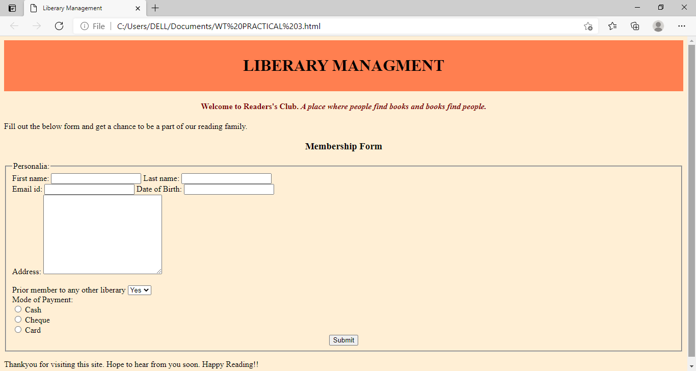

P4. Demonstrate the use of cascading style sheets (CSS) (inline, internal and external) to specify various aspects of style, such as colours and text fonts and sizes, in HTML document.

* EXTERNAL

<!DOCTYPE html>

<html>

<head> <title> External CSS</title>

<link rel="stylesheet" href="mystyle.css">

</head>

<body>

<h1><div>COVID-19: The Impact and Role of Mass Media during the Pandemic</div></h1>

<p class="p1"> <i>

“With 267k cases India becomes the 5th country to have the largest covid-19 cases in world wide” “Trump still holds china responsible for the outbreak of novel corona virus and demands answers” </i> </p>

<p class="p2">

These are some of the headlines we come across these days. Be it news, social media or newspapers, covid 19 has gained a column there. In these times, when we are confined within the four walls of our homes and most of lives have come to a halt, one thing that still has its wheels going on is mass media. It is the primary means of communication used to reach the vast majority of general public. People typically rely on the mass media to get information regarding political, cultural, social, and technological issues. Mass media holds the social, legal and ethical responsibilities in society and in a situation like this, the pandemic COVID-19, which questions the human existence, role and impact of mass media multiplies. Media acts as a mirror to the society: informative and reflective. <br>

It also plays a significant role in health communication by informing and updating us about the virus, its symptoms, precautions to be taken. Through sources like running adds, caller tunes and experts’ interviews it has repeatedly reminded us of the consequences and preventive measures. Comparing what the world knew about the virus when the first ever case was reported by WHO to what we know now, there is a significant addition and the credit goes to the mass media.

</p>

<hr>

To read more about Covid19 and related news click <a href= news.html> here</a>

</body>

</html>

* INLINE:

<!DOCTYPE html>

<html>

<head> <title> Inline CSS</title>

<link rel="stylesheet" href="mystyle.css">

</head>

<body style= "background-color: linen;">

<h1 style="color: maroon; margin-left: 40px;"><div style=" border-style: double; margin: 25px 50px 25px; background-color: LightBlue; font-family:"Footlight MT Light";">COVID-19: The Impact and Role of Mass Media during the Pandemic</div></h1>

<p class="p1" style="color: teal; font-size: 20px;"> <i>

“With 267k cases India becomes the 5th country to have the largest covid-19 cases in world wide” “Trump still holds china responsible for the outbreak of novel corona virus and demands answers” </i> </p>

<p class="p2" style="color: black; text-align: left; font-family: "Times New Roman", Times, serif; font-size: 25px;">

These are some of the headlines we come across these days. Be it news, social media or newspapers, covid 19 has gained a column there. In these times, when we are confined within the four walls of our homes and most of lives have come to a halt, one thing that still has its wheels going on is mass media. It is the primary means of communication used to reach the vast majority of general public. People typically rely on the mass media to get information regarding political, cultural, social, and technological issues. Mass media holds the social, legal and ethical responsibilities in society and in a situation like this, the pandemic COVID-19, which questions the human existence, role and impact of mass media multiplies. Media acts as a mirror to the society: informative and reflective. <br>

It also plays a significant role in health communication by informing and updating us about the virus, its symptoms, precautions to be taken. Through sources like running adds, caller tunes and experts’ interviews it has repeatedly reminded us of the consequences and preventive measures. Comparing what the world knew about the virus when the first ever case was reported by WHO to what we know now, there is a significant addition and the credit goes to the mass media.

</p>

<hr>

To read more about Covid19 and related news click <a href= news.html> here</a>

</body>

</html>

mystyle.css

body {

background-color: linen;

}

h1 {

color: maroon;

margin-left: 40px;

}

.p1 {

color: teal;

font-size: 20px;

}

.p2{

color: black;

text-align: left;

font-family: "Times New Roman", Times, serif;

font-size: 25px;

}

a {

color: red;

font-family: "Lucida Console", "Courier New", monospace;

}

div {

border-style: double;

margin: 25px 50px 25px;

background-color: LightBlue;

font-family:"Footlight MT Light";

}

* INTERNAL:

<!DOCTYPE html>

<html>

<head> <title> Internal CSS</title>

<style>

body {

background-color: linen;

}

h1 {

color: maroon;

margin-left: 40px;

}

.p1 {

color: teal;

font-size: 20px;

}

.p2{

color: black;

text-align:left;

font-family: "Times New Roman", Times, serif;

font-size: 25px;

}

a {

color: red;

font-family: "Lucida Console", "Courier New", monospace;

}

div {

border-style: double;

margin: 25px 50px 25px;

background-color: LightBlue;

font-family:"Footlight MT Light";

}

</style>

</head>

<body>

<h1><div>COVID-19: The Impact and Role of Mass Media during the Pandemic</div></h1>

<p class="p1"> <i>

“With 267k cases India becomes the 5th country to have the largest covid-19 cases in world wide” “Trump still holds china responsible for the outbreak of novel corona virus and demands answers” </i> </p>

<p class="p2">

These are some of the headlines we come across these days. Be it news, social media or newspapers, covid 19 has gained a column there. In these times, when we are confined within the four walls of our homes and most of lives have come to a halt, one thing that still has its wheels going on is mass media. It is the primary means of communication used to reach the vast majority of general public. People typically rely on the mass media to get information regarding political, cultural, social, and technological issues. Mass media holds the social, legal and ethical responsibilities in society and in a situation like this, the pandemic COVID-19, which questions the human existence, role and impact of mass media multiplies. Media acts as a mirror to the society: informative and reflective. <br>

It also plays a significant role in health communication by informing and updating us about the virus, its symptoms, precautions to be taken. Through sources like running adds, caller tunes and experts’ interviews it has repeatedly reminded us of the consequences and preventive measures. Comparing what the world knew about the virus when the first ever case was reported by WHO to what we know now, there is a significant addition and the credit goes to the mass media.

</p>

<hr>

To read more about Covid19 and related news click <a href= news.html> here</a>

</body>

</html>

**OUTPUT:**

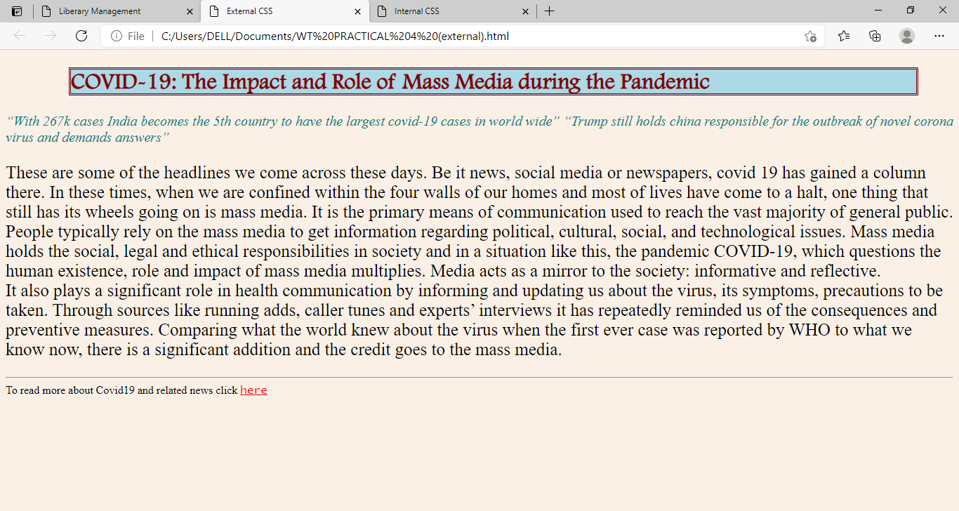

P5. Creation of Web pages using HTML5 and CSS3

<!DOCTYPE html>

<html>

<head>

<style>

#borderimg {

border: 10px solid transparent;

padding: 15px;

border-image: url(border.png) 30 stretch;

}

html{

background: url(paper.gif) left top repeat;

}

article {

column-count: 3;

column-gap: 40px;

column-rule: 1px dashed grey;

}

figcaption {

text-align: center;

font-style: italic;

font-size: smaller;

}

#example1 {

background: url(paper.gif) left top repeat;

padding: 15px;

}

</style>

</head>

<body><center>

<p id="borderimg" style="color: black; font-family: Times New Roman; font-size: 25px;">The Informative</p>

<canvas id="myCanvas" width="700" height="30" style="border:1px solid black;"></canvas></center>

<script>

var canvas = document.getElementById("myCanvas");

var ctx = canvas.getContext("2d");

ctx.font = "15px Comic Sans MS";

ctx.fillStyle = "red";

ctx.textAlign = "center";

ctx.fillText("Informing Since 1895", canvas.width/2, canvas.height/2);

</script>

<br>

<div class="container">

<article>

<p><h4>TCyclone Tauktae live updates: Weakened cyclone moves north, Delhi-NCR braces for rain</h4>

The landfall process of the eye of extremely severe cyclonic storm Tauktae, which hit the Gujarat coast in Saurashtra region between Diu and Una, ended around midnight, the India Meteorological Department said on Tuesday. State officials said there are no reports of any casualty due to the tropical storm 'Tauktae' (pronounced as Tau'Te), adding it has weakened. The IMD also announced that the cyclone has weakened into a 'very severe cyclonic storm' from the 'extremely severe cyclonic storm'. Stay with TOI for latest updates. </p>

<p><h4>Covid-19: Didn't export vaccines at the cost of the people in India, says Adar Poonawalla</h4>

Serum Institute of India CEO Adar Poonawalla on Tuesday issued a statement saying that the company has not exported Covid-19 vaccines at the cost of the people of India.

Poonawalla said the vaccination drive for such a large population cannot be completed within 2-3 months and it would take 2-3 years for the entire world population to get fully vaccinated.</p>

</body>

</html>

**OUTPUT:**

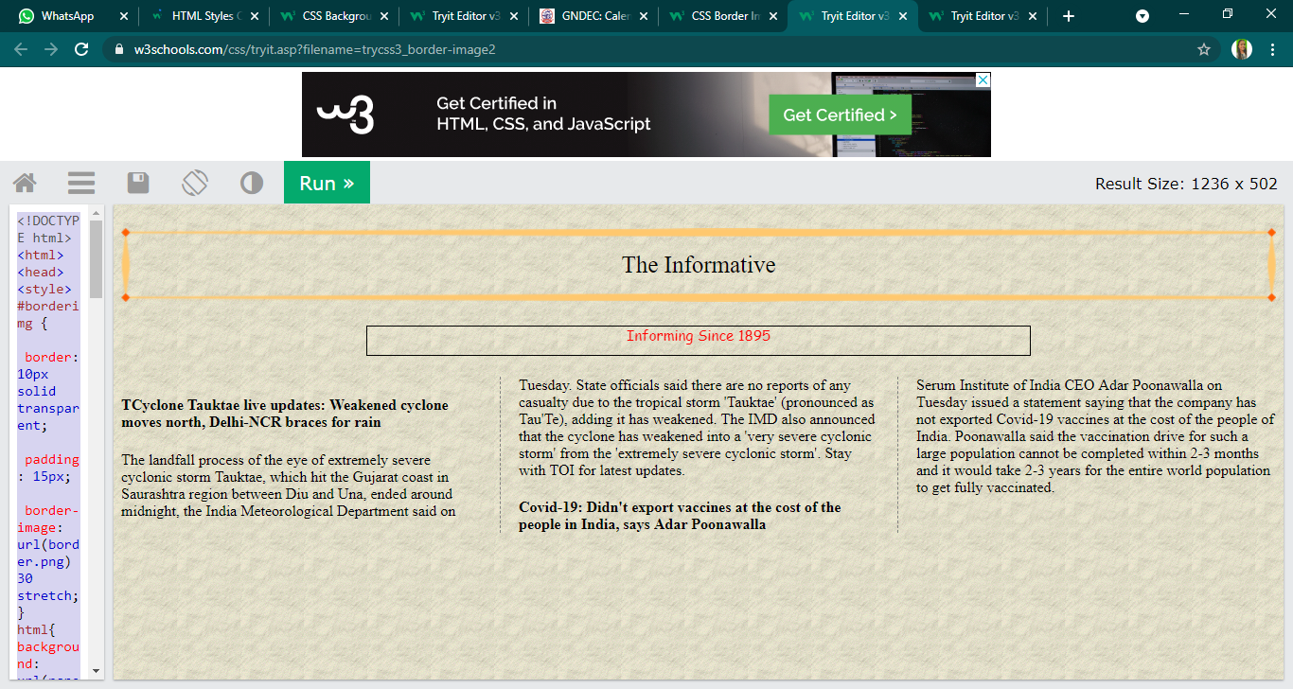

P6. Demonstrate the use of Bootstrap Framework.

<!DOCTYPE html>

<html lang="en">

  <head>

    <meta charset="UTF-8" />

    <meta http-equiv="X-UA-Compatible" content="IE=edge" />

    <meta name="viewport" content="width=device-width, initial-scale=1.0" />

    <title>Practical 6</title>

    <link

      rel="stylesheet"

[href="https://cdn.jsdelivr.net/npm/bootstrap@4.6.0/dist/css/bootstrap.min.css](mailto:href=%22https://cdn.jsdelivr.net/npm/bootstrap@4.6.0/dist/css/bootstrap.min.css)"

      integrity="sha384-B0vP5xmATw1+K9KRQjQERJvTumQW0nPEzvF6L/Z6nronJ3oUOFUFpCjEUQouq2+l"

      crossorigin="anonymous"

    />

  </head>

  <body style="padding: 50px">

    <nav class="navbar navbar-expand-lg navbar-dark bg-dark">

      <a class="navbar-brand" href="#">Navbar</a>

      <button

        class="navbar-toggler"

        type="button"

        data-toggle="collapse"

        data-target="#navbarTogglerDemo02"

        aria-controls="navbarTogglerDemo02"

        aria-expanded="false"

        aria-label="Toggle navigation"

      >

        <span class="navbar-toggler-icon"></span>

      </button>

      <div class="collapse navbar-collapse" id="navbarTogglerDemo02">

        <ul class="navbar-nav mr-auto mt-2 mt-lg-0">

          <li class="nav-item active">

            <a class="nav-link" href="#"

              >Home <span class="sr-only">(current)</span></a

            >

          </li>

          <li class="nav-item">

            <a class="nav-link" href="#">Link</a>

          </li>

          <li class="nav-item">

            <a

              class="nav-link disabled"

              href="#"

              tabindex="-1"

              aria-disabled="true"

              >Disabled</a

            >

          </li>

        </ul>

        <form class="form-inline my-2 my-lg-0">

          <input

            class="form-control mr-sm-2"

            type="search"

            placeholder="Search"

          />

          <button class="btn btn-outline-success my-2 my-sm-0" type="submit">

            Search

          </button>

        </form>

      </div>

    </nav>

    <br />

    <div class="alert alert-success" role="alert">

      <h4 class="alert-heading">Well done! </h4>

      <p>

        Aww yeah, you successfully read this important alert message. This

        example text is going to run a bit longer so that you can see how

        spacing within an alert works with this kind of content.

      </p>

      <hr />

      <p class="mb-0">

        Whenever you need to, be sure to use margin utilities to keep things

        nice and tidy.

      </p>

    </div>

    <br />

    <form class="needs-validation" novalidate style="margin: 0 50px">

      <div class="form-row">

        <div class="col-md-6 mb-3">

          <label for="validationTooltip01">First name</label>

          <input

            type="text"

            class="form-control"

            id="validationTooltip01"

            placeholder="Mark"

            required

          />

          <div class="valid-tooltip">Looks good! </div>

        </div>

        <div class="col-md-6 mb-3">

          <label for="validationTooltip02">Last name</label>

          <input

            type="text"

            class="form-control"

            id="validationTooltip02"

            placeholder="Zukerberg"

            required

          />

          <div class="valid-tooltip">Looks good! </div>

        </div>

      </div>

      <div class="form-row">

        <div class="col-md-6 mb-3">

          <label for="validationTooltip03">City</label>

          <input

            type="text"

            class="form-control"

            id="validationTooltip03"

            required

          />

          <div class="invalid-tooltip">Please provide a valid city. </div>

        </div>

        <div class="col-md-3 mb-3">

          <label for="validationTooltip04">State</label>

          <select class="custom-select" id="validationTooltip04" required>

            <option selected disabled value="">Choose...</option>

            <option>...</option>

          </select>

          <div class="invalid-tooltip">Please select a valid state. </div>

        </div>

        <div class="col-md-3 mb-3">

          <label for="validationTooltip05">Zip</label>

          <input

            type="text"

            class="form-control"

            id="validationTooltip05"

            required

          />

          <div class="invalid-tooltip">Please provide a valid zip.</div>

        </div>

      </div>

      <button class="btn btn-primary" type="submit">Submit form</button>

    </form>

  </body>

</html>

**OUTPUT:**

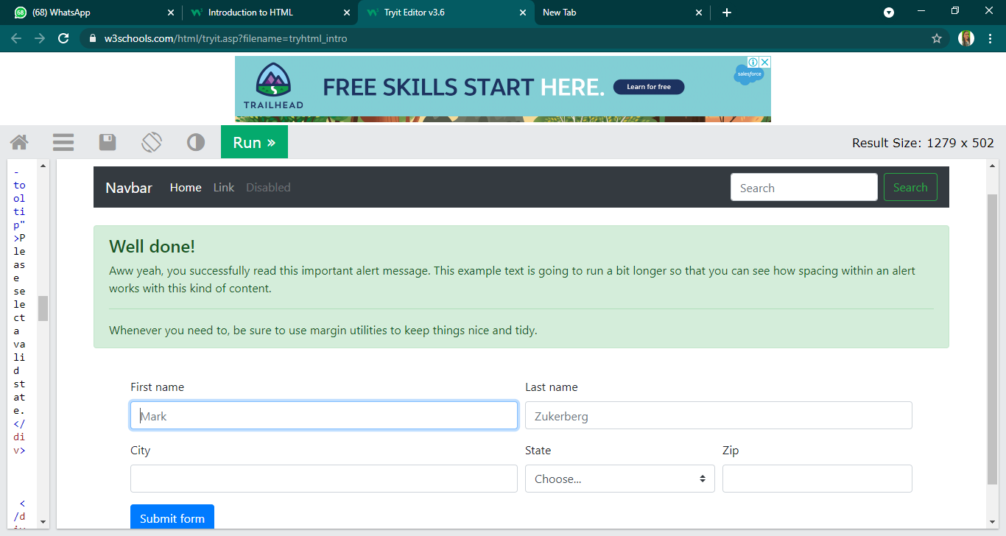

P7. Creating web pages using PHP.

HTML:

<!DOCTYPE html>

<html lang="en">

  <head>

    <meta charset="UTF-8" />

    <meta http-equiv="X-UA-Compatible" content="IE=edge" />

    <meta name="viewport" content="width=device-width, initial-scale=1.0" />

    <title>Practical 7</title>

    <link rel="stylesheet" href="./Practical-7.css" />

  </head>

  <body>

    <div class="contact-title">

      <h1>Welcome To This Website</h1>

      <h2>We Are Happy To Help You</h2>

    </div>

    <div class="contact-form">

      <form action="Practical-7.php" method="POST" id="contact-form">

        <input

          type="text"

          name="name"

          class="form-control"

          placeholder="Your Name"

          required

        />

        <br />

        <input

          type="email"

          name="email"

          class="form-control"

          placeholder="Your Email"

          required

        />

        <br />

        <textarea

          name="message"

          class="form-control"

          placeholder="Message"

          rows="4"

          required

        ></textarea>

        <br />

        <input type="submit" class="form-control submit" value="Send message" />

      </form>

    </div>

  </body>

</html>

CSS:

body {

  margin: 0;

  padding: 0;

  text-align: center;

  background: rgb(34, 36, 0);

  background: linear-gradient(

    215deg,

    rgba(34, 36, 0, 1) 6%,

    rgba (9, 121, 118, 1) 51%,

    rgba 132, 0, 255, 1) 86%

  );

  background-repeat: no-repeat;

  height: 100%;

  background-attachment: fixed;

  background-position: center;

}

.contact-title {

  margin-top: 100px;

  color: #fff;

  text-transform: uppercase;

  transition: all 4s ease-in-out;

}

.contact-title h1 {

  font-size: 32px;

  line-height: 10px;

}

.contact-title h2 {

  font-size: 16px;

}

form {

  margin-top: 50px;

  transition: all 4s ease-in-out;

}

.form-control {

  width: 600px;

  background: transparent;

  border: none;

  outline: none;

  border-bottom: 1px solid #333;

  color: #fff;

  font-size: 18px;

  margin-bottom: 16px;

}

input {

  height: 45px;

}

form .submit {

  background: #ff5722;

  border-color: transparent;

  color: #fff;

  font-size: 20px;

  font-weight: bold;

  letter-spacing: 2px;

  height: 50px;

  margin-top: 20px;

}

form. submit: hover {

  background-color: #f44;

  cursor: pointer;

}

PHP:

<?php

    $name=$_POST['name'];

    $visitor_email=$_POST['email'];

    $message=$_POST['message'];

[$email_from='astha1921016@gndec.ac.in](mailto:$email_from='guriqbal1921032@gndec.ac.in)';

    $email_subject="New Form Submission";

    $email_body="User Name: $name.\n"."User Email: $visitor_email.\n"."User Message: $message.\n";

[$to="kumarsharan1165@gmail.com](mailto:$to=%22kumarsharan1165@gmail.com)";

    $headers="From: $email_from \r\n";

    $headers .="Reply-To: $visitor_email \r\n";

    mail ($to, $email_subject, $email_body, $headers);

    header("Location: Practical-7.html");

?>

**OUTPUT:**